37.25: a) 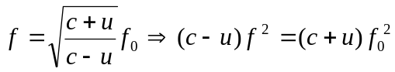
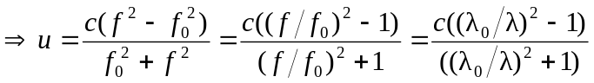
b) million dollars!

